NAME: login ID: Precept (circle one): P01 P01A P01B P02 P02A P03

COS 226 Midterm Exam, Spring 2011
This test is 9 questions, weighted as indicated. The exam is closed book, except that you are allowed to use a one page cheatsheet. No calculators or other electronic devices are permitted. Give your answers and show your work in the space provided. Put your name, login ID, and precept number on this page (now), and write out and sign the Honor Code pledge before turning in the test. You have 80 minutes to complete the test.
"I pledge my honor that I have not violated the Honor Code during this examination."
1 /12 2 /10 3 /10 4 /10 5 /14 6 /10 7 /10 8 /14 9 /10 TOTAL /100
1. Partitioning (12 points).
A. (4 points) Fill in the diagram below with the result of partitioning the array with standard quicksort partitioning (taking the E at the left as the partitioning item). Also give the number of exchanges.
E V E R Y E Q U A L K E Y S T O P S I T
Number of exchanges _________
B. (3 points) Why does standard quicksort partitioning stop the partitioning scans on keys equal to the partitioning item? Circle your answer.
a. It is a lazy algorithm.
b. To avoid exchanging them.
c. To avoid quadratic running time.
d. To make the algorithm stable.
e. None of the above.

C. (5 points) Fill in the diagram below with the result of partitioning the array with 3-way quicksort partitioning (again taking the E at the left as the partitioning item). Also give the number of exchanges.
E V E R Y E Q U A L K E Y S T O P S I T
Number of exchanges ___________
2. Estimating order of growth (10 points).
A. (5 points) Suppose that you observe that a program takes 30 seconds to complete on inputs of size 600 and 4.5 minutes to complete on inputs of size 1800. Develop a reasonable hypothesis for the order of growth of the running time. Hint: Use a tripling hypothesis.
order of growth: ____________
B. (5 points) Suppose that you observe that a program takes x seconds to complete on inputs of size N and y seconds to complete on inputs of size 10N. Under the hypothesis that the order of growth of the running time is N to a power b, give a formula for b.
b = ____________
3. Sorting algorithms (10 points). Give the order of growth of the running times of the following sorting algorithms for arrays that are already in order and for arrays that are in reverse order. For quicksort, note that it randomizes, so give the expected order of growth. Write constant, N, N log N, N2, or ? in each blank. Fill in all blanks and use exactly one question mark (in other words, there is one answer that we think is an open research question).
sorted order reverse order
a. Quicksort ______________ ________________
b. Heapsort ______________ ________________
c. Insertion sort ______________ ________________
d. Selection sort ______________ ________________
e. Shellsort ______________ ________________ (with increments 1, 4, 13, 40, ...)

4. Tree height (10 points). Write constant, log N, log*N, or N in the blank following each of the following tree structures to best describe the order of growth of the height of an N-node tree in the best case and in the worst case.
best case worst case
a. BST ___________ __________
b. Heap-ordered complete tree ___________ __________
c. Left-leaning red-black tree ___________ __________
d. quick-union with path compression ___________ __________
e. weighted quick-union ___________ __________

5. LLRB insertion (14 points). The following diagram shows a left-leaning red-black BST Thick lines are red links.
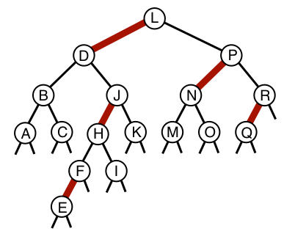
a. (5 points) Draw the left-leaning red-black BST that results after S is inserted.
b. (2 points) Which of the trees drawn below are legal left-leaning red-black BSTs? In the blank below, write the numbers corresponding to all legal LLRB BSTs. Do not include trees that might arise at intermediate stages of an insertion.

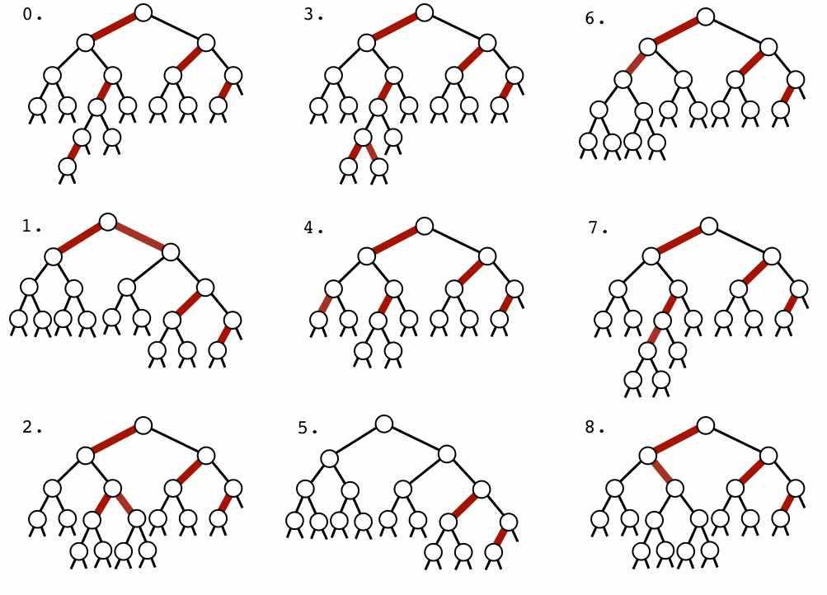
Legal LLRB trees _________________________
c. (7 points) Seven of the trees drawn above are intermediate stages when a new key is inserted into tree 0. In the blanks below, list the numbers corresponding to these trees (not including tree 0) in the order in which they occur during the insertion process.
_____ _____ _____ _____ _____ _____ _____
6. Heap operations (10 points). Consider the following max-heap:
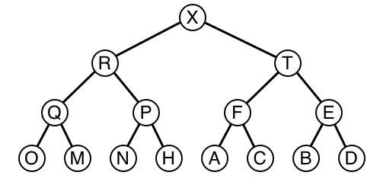
a. (5 points) Draw the result of inserting S.
b. (5 points) Draw the result of deleting the maximum from the original max-heap shown above (before S has been inserted).

7. Linear probing (10 points). A programmer building a symbol-table with single-character keys uses a bad hash function where keys in the first half of the alphabet (A through M) hash to the value 6 and keys in the second half of the alphabet (N through Z) hash to the value 9.
A. (6 points) Fill in the diagram below to give the result of inserting the keys
B A D F U N C T I O N
into an initially empty table of size 11 with this hash function.
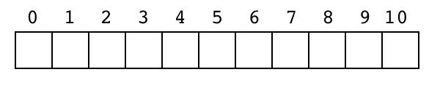
B. (4 points) Suppose that the same programmer has the same problem with N keys (half the keys hash to the value 6 and the other half hash to the value 9). Answer the following questions about the order of growth of the running time for certain operations by filling in the blanks below with one of the words constant, linear, linearithmic, or quadratic. For linear probing assume the array size to be 2N; for separate chaining, assume the array size to be N/5.
a. Average time for a search hit with separate chaining _____________ when searching for a random key
b. Average time for a search hit with linear probing _____________ when searching for a random key
c. Total time to build the table with linear probing _____________
d. Total time to build the table with separate chaining _____________

8. 7 sorting algorithms (14 points). The leftmost column is the original input of strings to be sorted, and the rightmost column is the sorted result. The other columns are the contents at some intermediate step during one of the 7 sorting algorithms listed below. Match up each algorithm by writing its letter under the corresponding column. Use each letter exactly once.
that from been good your been from have been with good from have with that have that from have have good been will good know that good this that have know this have that this have that been know from they from that will know will that that that want that that will that will know that that will know they with that your that that that that that this your that from your that that from that will from that they they they they that they will know they know will this your know will with that this that will want want that this your they want want want will will have want want been will been that your will been will been good will that this with this that with that that with good with will with good your good want your
input __ __ __ __ __ __ __ result
a. 3-way quicksort (with no random shuffle)
b. Shellsort (13-4-1 increments)
c. Insertion sort
d. Quicksort (with no random shuffle)
e. Selection sort
f. Top-down mergesort
g. Heapsort

9. Maximum difference (10 points). Consider the following code fragment which computes the maxdiff function for an array: the maximum value of the difference between an entry and an entry to its left. For example, the maxdiff of {3, 1, 4, 1, 5, 9, 2}is 8 because the difference between the 9 and the 1s to its left is 8 and no other difference between an entry and another entry to its left is greater. As another example the maxdiff of {9, 4, 6, 8, 2, 2}is 4.
public static int slow(int[] a)
{ int max = a[1] - a[0]; for (int j = 2; j < a.length; j++)
for (int i = 0; i < j; i++) if (a[j] - a[i] > max) max = a[j] - a[i]; return max; }
An enterprising COS226 student figured out a faster way to solve the problem, with the following code:
public static int fast(int[] a)
{ int max = a[1] - a[0]; int min = a[0]; for (int k = 1; k < a.length; k++) {
// First missing line of code.
// Second missing line of code. } return max;
}
A. (8 points) In the space below, write the two lines of code missing from fast(). A "line of code" is a statement ending with a semicolon.
_________________________________________________________
_________________________________________________________
B. (2 points) What is the order of growth of the running time of the two methods? Write one of the following words in each of the blanks below: constant, linear, linearithmic, quadratic, cubic.
slow() __________________
fast() __________________

